

Name of Note Taker | Pat Lattimer
Date | 19/06/24
Meeting Topic | Healthwatch Board Meeting
Attendees | Phil Turner Chair  Pat Lattimer Director, Acting CEO  Steph Power Director  Maureen Matthews Volunteer Champion Lead

Agenda:
- Update on activity PL
- Finance update PT
- Staff position and recruitment PT/PL
- AOB

- Activity update
  - PT and PL met with the commissioners to provide update on current activity and provide assurance on contract delivery.
  - HW are supporting LBC with the consultation process for Luton all health strategy. Three focus groups being run with CYP
  - Three focus groups have been held at the 6th form college collecting feedback in support of the women’s health project
  - HWL have attended the Men’s Health event Mecca Bingo and Picnic in the park providing awareness and support in engagement.
  - REN initial project completed and continue working with REN champions for ongoing sustainability
  - MSK project completed
  - ICB Denny projects in planning stage.
- Finance update
  - Period 2 2024-2025 is running at 1.2% over budgeted spend.
  - Budget is set at 84.8% of funds available for financial year
  - Staff turnover is anticipated to create an increase in one off costs therefore an overspend to budget over the next two periods but will remain within available funds.
- Staff update
  - Discussed current vacancies in HWL and to advertise for Communications Officer and an administrator. SP to review job descriptions. PL to organise advertisement on HW web site and elsewhere Action SP, PL
  - There is a need to fully document processes regarding White Bear and Hootsuite. Action PL
  - Obtain overview of staff leave from SA Action PL
.
There being no further business the meeting was closed

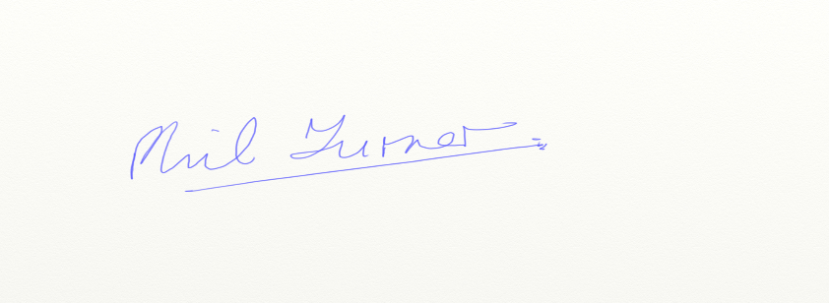
Phil Turner
Chair 19/06/2024

